SSL VPN Installation Guide

First delete the exciting VPN file and follow the steps mentioned below to upload a new VPN configuration file. Then connect and it will work

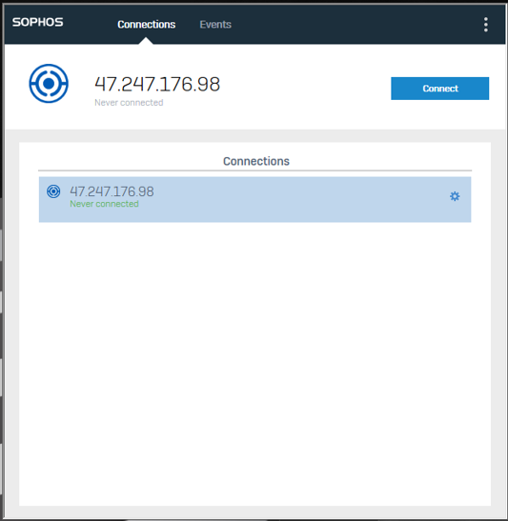
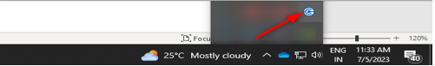

Step 1: Open the Browser and enter https://47.247.176.98 and click on Advanced and then Click on Proceed to 47.247.176.98(unsafe)
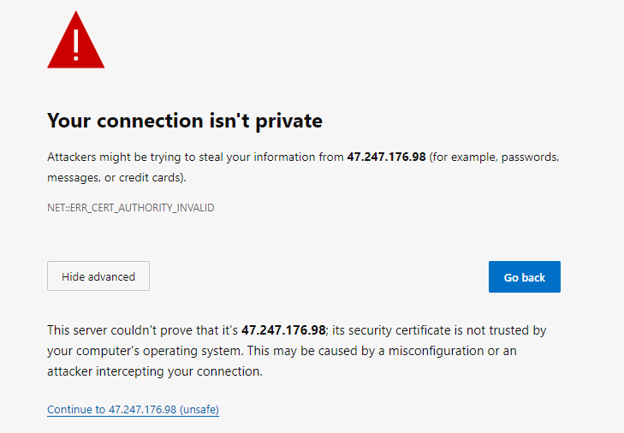

Step 2: Enter your Windows Username and Password

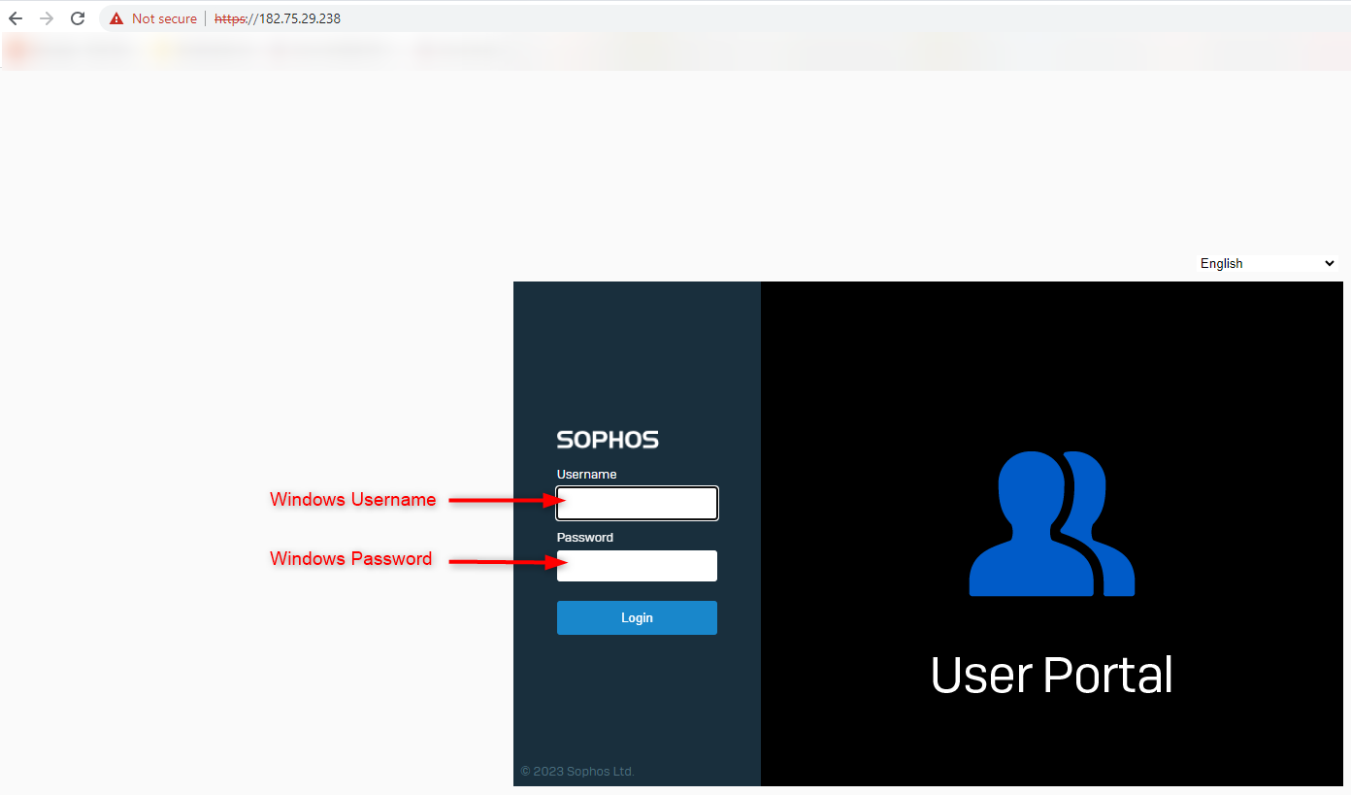

Step 3: Click on the “Download for Windows” button under VPN Configuration as shown in the below screen to download the SSL VPN Configuration.

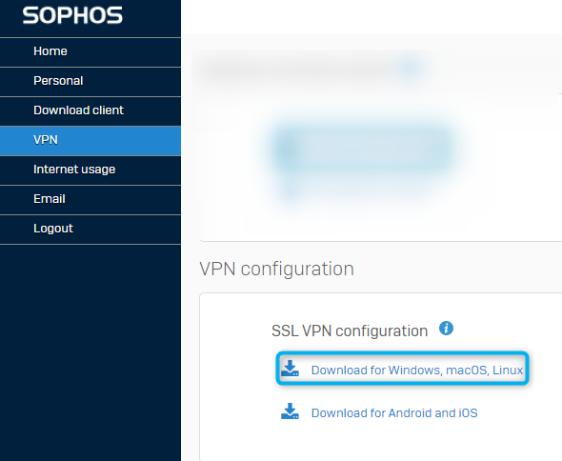

Step 5: Click on the below Sophos Connect icon under task bar as shown in the below screen and click on the “Import connection” and open the SSL VPN configuration file which has been downloaded.
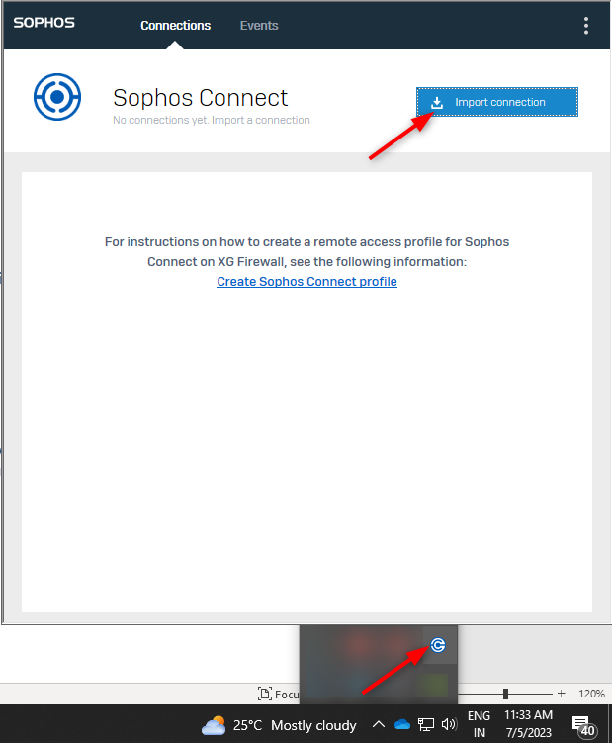

Step 6: Once the Import connection is completed, you can able to see the IP address listed. Click on the “Connect” button.

(Note: Existing VPN Users click on the wheel like icon near to the IP Address and click on delete.)
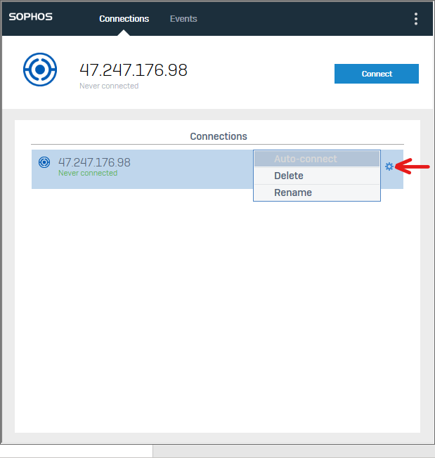

Step 7: In “Authenticate User”, please enter your Windows login credentials and click on “Sign In” button to connect to the VPN.

